Del Webb – Fitness Class Schedule
Pendleton Center Phone Number 928-759-5920
*Classes are subject to change*

MONDAYS  7:00am-12:00pm  1:00pm-4:00pm | TUESDAYS  7:00am-12:00pm | WEDNESDAYS  7:00am-12:00pm  1:00pm-4:00pm | THURSDAYS  7:00am-12:00pm | FRIDAYS  7:00am-12:00pm  1:00pm-4:00pm
9:00 am  Silver Sneakers  Classic |  | 8:00 am  Ener-Chi/Stretch | 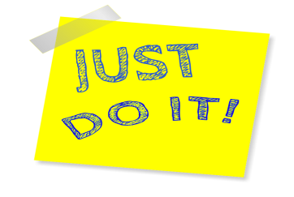 | 9:00 am  Silver Sneakers Classic
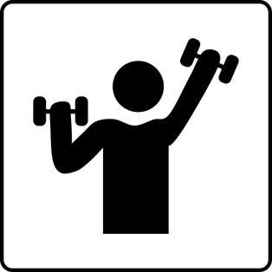 | 9:00 am  Silver Sneakers Circuit | 9:00 am  Silver Sneakers  Circuit | 9:00 am  Silver Sneakers Circuit
10:00 am  Balance & Strength |  | 10:00 am  Balance & Strength |  | 10:00 am  Balance & Strength
11:00 am  Silver & Fit Explore |  | 11:00 am  Silver & Fit Explore | 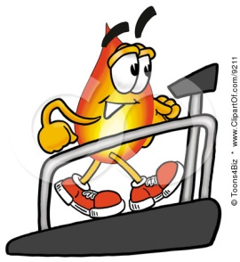 | 11:00 am  Silver & Fit Explore
*Class size is limited. Please contact the fitness center to sign up. Please call if unable to attend a class*

Fitness Class Descriptions – Del Webb

Ener-Chi/Stretch: combines modified tai chi forms and qigong exercises to promote wellness. Purposeful movement performed with awareness and focused breathing cultivates a strong, balanced body and a calm mind.

Silver & Fit Explore: This is a great class for beginner level members. This is a gentler, slower workout, with seated or standing exercise options. A goal of this program is to enable the older adult who does require in chair exercise to progress to freely stand and be stable. A chair is used for seated exercises and standing support. Hand-held weights, elastic tubing with handles and a ball are used for resistance.

Balance & Strength: Energetic class for adults who want to work on strength, balance, posture, and improve daily activities. A goal of this program is to increase cardiovascular endurance and strength. A chair is used for seated exercises and standing support. Hand-held weights, elastic tubing with handles and a ball are used for resistance. This is an intermediate level class.

Silver Sneakers Classic: Have fun and move to the music through a variety of exercises designed to increase muscular strength, range of movement and activities for daily living. Hand-held weights, elastic tubing with handles and a Silver Sneakers ball are offered for resistance. A chair is available if needed for seated or standing support. This is an intermediate level class.

Silver Sneakers Circuit: Combine fun with fitness to increase your cardiovascular and muscular endurance power with a standing circuit workout. Upper-body strength work with hand-held weights, elastic tubing with handles, and a Silver Sneakers ball is alternated with low-impact aerobics choreography. A chair is used for standing support, stretching and relaxation exercises. This is an intermediate to advanced level class.

